Marina Marco
CS 499 Module One

- Self-Introduction
  - Address all the following questions to introduce yourself:
    - How long have you been in the Computer Science program?
      - I have been in the program since July 2024.
    - What have you learned while in the program? List three of the most important concepts or skills.
      - I have learned a lot of useful information about data structures, software design, and algorithms along with many different topics that align with programming.
      - Three of many important concepts that I have learned throughout my education are:
        - Design Patterns
          - How to organize code to help maintain, scale and reuse.
        - Data Structures
          - Optimize performance, and memory management by organizing and storing data using arrays, list, trees, and graphs.
        - Database Management
          - Creating databases, SQL queries and being able to manage data storage.
    - Discuss the specific skills you aim to demonstrate through your enhancements to reach each of the course outcomes.
      - The enhancements will show improvement in design, efficiency and security, which will show how I grew throughout the course to be able to see areas of improvement and implement the improvements.
    - How do the specific skills you will demonstrate align with your career plans?
      - I currently work on the IT side in the financial world. I will be growing my knowledge to improve my current work and be able to assist other teams with more complex items.
    - How does this contribute to the specialization you are targeting for your career?
      - This gives me more options and opportunities for growth within my current company, offering more career choices.
- ePortfolio Set Up
  - Submit a screen capture of your ePortfolio home page that clearly shows your URL.
    - Access GitHub Pages, the platform you will use to build your ePortfolio.
    - Follow the instructions for setting up an account and profile with GitHub Pages.
      - 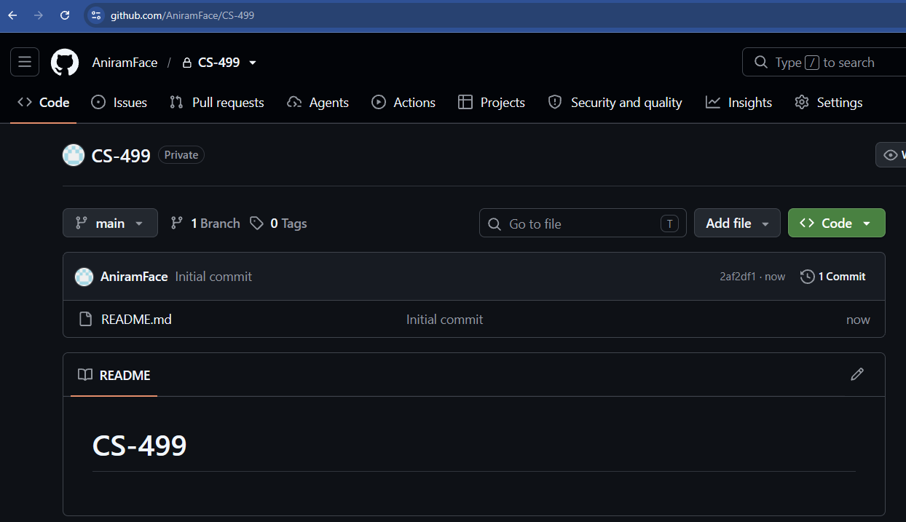
- Enhancement Plan
  - Category One: Software Engineering and Design
    - Select an artifact that is aligned with the category and explain its origin.
      - IT-145
        - This project is a boarding facility for dogs and cats where you can create and check in animals and be able to verify if there is room to board the animal.
      - I picked this project because it showcases designing a system that can review animals based on multiple traits and be able to add them to the system and check current count to see if they are booked.
    - Describe a practical, well-illustrated plan for enhancement in alignment with the category, including a pseudocode or flowchart that illustrates the planned enhancement.
      - This project was completed in java, and I am going to redo it in Visual Studios to build the project. I noticed that my work was not built correctly and will need to start from scratch. Here is the outline of the format of how it should work.
Checking in Process
- Start
  - Menu
    - Show Registered
    - Register
    - Check in
    - Check out
    - Exit
  - Show Registered
    - Registered pets
    - Pets checked in
    - Menu
  - Registered
    - Enter pet’s name
    - Enter pet’s age
    - Pet Type
  - Check in
    - Enter pets ID
  - Check out
    - Enter pets ID
  - Exit

    - Explain how the planned enhancement will demonstrate specific skills and align with course outcomes.
      - Course outcomes are listed in the assignment template. Refer to the Final Project Guidelines and Rubric for more details on course outcomes.
        - This will solve being able to design a program that solves a problem. I am creating a new system that can assist in checking in animals. I am going to create with best practices and make sure its clean code.
  - Category Two: Algorithms and Data Structures
    - Select an artifact that is aligned with the category and explain its origin.
      - IT-145
        - This project is a boarding facility for dogs and cats where you can create and check in animals and be able to verify if there is room to board the animal.
      - I picked this project because I want to improve on the current code for both dog and cat (new from above). I want to make sure the code is clean and you can go through the flow easily and be able to see the animals.
    - Describe a practical, well-illustrated plan for enhancement in alignment with the category, including a pseudocode or flowchart that illustrates the planned enhancement.
      - The plan is to go through the code and look for loose ends. I want to make sure when you check in the animals, you can only check in based on the limit that there. I want to make sure the system is simple enough that anyone can work through it. I also want to make sure the code is clean, adding in comments letting you know what the specific code is and making it run properly. I would like to organize it so it’s not all in one section like the current code.
    - Explain how the planned enhancement will demonstrate specific skills and align with course outcomes.
      - Course outcomes are listed in the assignment template. Refer to the Final Project Guidelines and Rubric for more details on course outcomes.
        - I am producing code that shows technique, skills and tools in computing practices for giving a solution that delivers value and accomplish industry-specific goals.
  - Category Three: Databases
    - Select an artifact that is aligned with the category and explain its origin.
      - IT-145
        - This project is a boarding facility for dogs and cats where you can create and check in animals and be able to verify if there is room to board the animal.
      - I picked this project because I wanted to use one project and show all my skills with it. My original code was not built to work, and it will take time to build a running program that fits all three categories.
    - Describe a practical, well-illustrated plan for enhancement in alignment with the category, including a pseudocode or flowchart that illustrates the planned enhancement.
      - I am not 100% of how I will do this work. I am going to continue to do research on what I would like to do to complete this category. I will make sure I add some kind of database to host the data inputted for this so past data will not be lost. Every time you open the project, the information does not save so want to make sure I can retain the info.
    - Explain how the planned enhancement will demonstrate specific skills and align with course outcomes.
      - Course outcomes are listed in the assignment template. Refer to the Final Project Guidelines and Rubric for more details on course outcomes.
        - I will input a system that will help eliminate vulnerabilities in the program.
- ePortfolio Overall Skill Set
  - Accurately describe the skill set to be illustrated by the ePortfolio overall.
    - Skills and outcomes planned to be illustrated in the code review
      - Being able to audit the code to find vulnerabilities, inefficiencies and flaws.
      - Showing knowledge of industry best practices.
      - Identifying security risk.
    - Skills and outcomes planned to be illustrated in the narratives
      - Documenting enhancements, showing the issue and solution.
      - Reflecting on the challenges faced during the updates.
    - Skills and outcomes planned to be illustrated in the professional self-assessment
      - Honestly assessing myself and my work, showing strengths and weaknesses.
      - Connecting skills to roles and responsibilities I would like to have as part of my career.
      - Setting myself for career readiness outlining a clear roadmap for development.

